ECE 4560 - Homework 7
Brett Erickson
1.
a)
L1 = 2;
L2 = 4;

x = 7;
y = 0;
alpha = acos((x^2+y^2+L1^2-L2^2)/(2*L1*sqrt(x^2 + y^2)));
beta = acos((L1^2+L2^2-x^2-y^2)/(2*L1*L2));
gamma = atan2(0,7);
theta_1 = gamma - alpha;
theta_2 = pi - beta;

fprintf("Righty joint angles - Theta 1: %f radians \n Theta 2: %f radians",theta_1, theta_2);
Righty joint angles - Theta 1: 0.000000 radians
Theta 2: 0.000000 radians

theta_1 = gamma + alpha;
theta_2 = beta - pi;

fprintf("Lefty joint angles - Theta 1: %f radians \n Theta 2: %f radians",theta_1, theta_2);
Lefty joint angles - Theta 1: 0.000000 radians
Theta 2: 0.000000 radians
Given that the point (7,0) is not within the arm workspace, the alpha and beta functions yield imaginary numbers and throw off the rest of the calculation.

b)
x = 3;
y = 3;
alpha = acos((x^2+y^2+L1^2-L2^2)/(2*L1*sqrt(x^2 + y^2)));
beta = acos((L1^2+L2^2-x^2-y^2)/(2*L1*L2));
gamma = atan2(0,7);
theta_1 = gamma - alpha;
theta_2 = pi - beta;

fprintf("Righty joint angles - Theta 1: %f radians \n Theta 2: %f radians",theta_1, theta_2);
Righty joint angles - Theta 1: -1.209429 radians
Theta 2: 1.696124 radians

theta_1 = gamma + alpha;
theta_2 = beta - pi;

fprintf("Lefty joint angles - Theta 1: %f radians \n Theta 2: %f radians",theta_1, theta_2);
Lefty joint angles - Theta 1: 1.209429 radians
Theta 2: -1.696124 radians
L1 = 2;
L2 = 4;

c)
x = -2;
y = 2;
alpha = acos((x^2+y^2+L1^2-L2^2)/(2*L1*sqrt(x^2 + y^2)));
beta = acos((L1^2+L2^2-x^2-y^2)/(2*L1*L2));
gamma = atan2(0,7);
theta_1 = gamma - alpha;
theta_2 = pi - beta;

fprintf("Righty joint angles - Theta 1: %f radians \n Theta 2: %f radians",theta_1, theta_2);
Righty joint angles - Theta 1: -1.932163 radians
Theta 2: 2.418858 radians

theta_1 = gamma + alpha;
theta_2 = beta - pi;

fprintf("Lefty joint angles - Theta 1: %f radians \n Theta 2: %f radians",theta_1, theta_2);
Lefty joint angles - Theta 1: 1.932163 radians
Theta 2: -2.418858 radians

2.
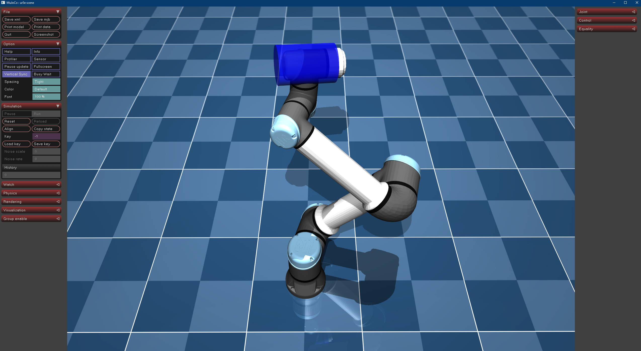
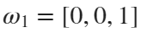, 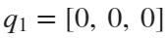
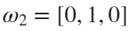, 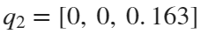
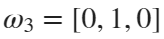, 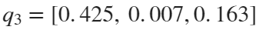
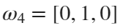, 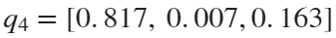
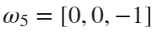, 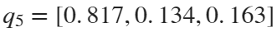
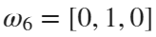, 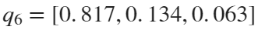
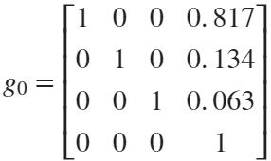

3.

Success: 1
Crushing failure: 4
b)
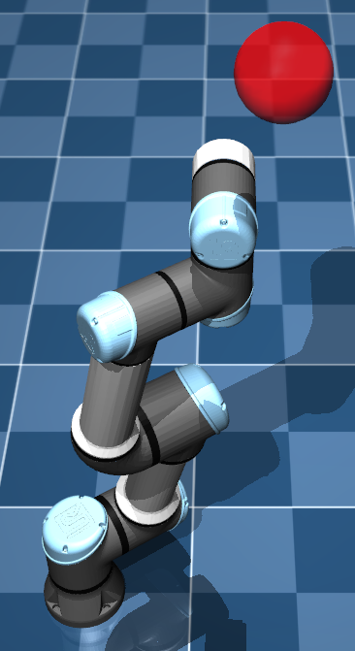
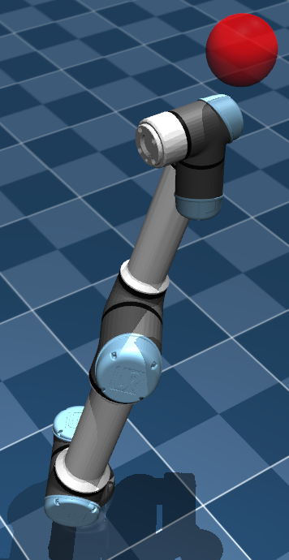
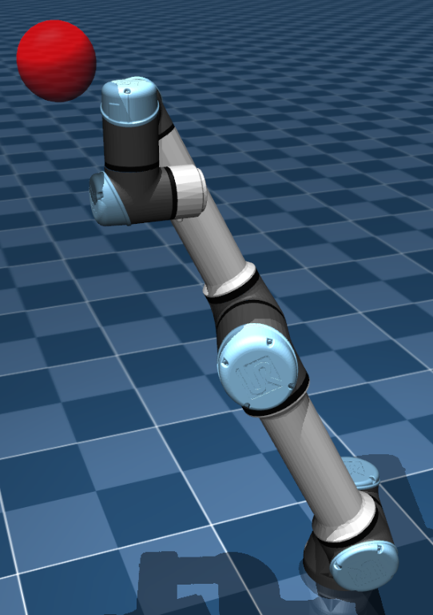
where the method to minimize is the Broyden–Fletcher–Goldfarb–Shanno algorithm.
